Closed Sort on Sheltered Instruction Strategies

Hands-On Activities | Cooperative Learning | Guarded Vocabulary | Visuals

Program Services Plan Accommodations
Word Bank

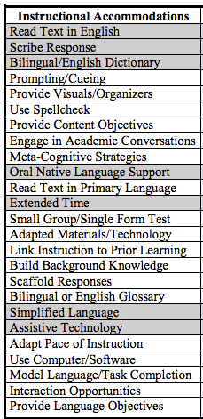

SIOP Word Bank

